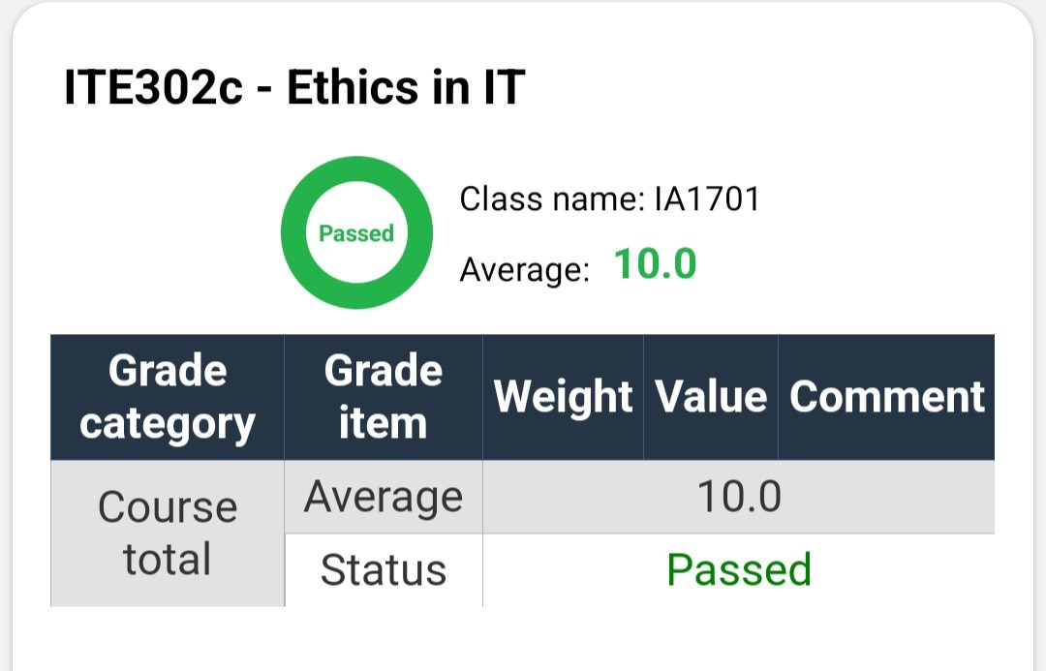

CHỎ VÀO LINK VÀ Ctrl + click nhé!

* 1/ Link quizlet: Học hai source này vô 100%
* [Quizlet ITE303c](https://quizlet.com/vn/725978049/ite303c-new-flash-cards/?fbclid=IwAR1WZTuofhXD88Jwty6rwD6Bir40syX-x3dAkGXhptuvuJA-pKWsq9lBDh0) (học)
* [Quizlet 593 câu](https://quizlet.com/608594096/ite302c-flash-cards/?x=1jqt) (học)
* [Quizlet 477 câu](https://quizlet.com/vn/607997539/ite302c-all-flash-cards/?x=1jqt)
* [Quizlet 240 câu](https://quizlet.com/vn/597554534/ite302c-flash-cards/)
* [Quizlet 233 câu](https://quizlet.com/vn/597823989/ite302c-full-flash-cards/)
* 2/ Đề FE:

1. [ITE302c FA-21](https://docs.google.com/presentation/d/1HtsuxloO1Ym_Pob0_v5IdHAUPtrDsHWILFiLir53pcs/edit?usp=sharing) [SOURCE](https://www.facebook.com/groups/319495429750576/?multi_permalinks=441879450845506&ref=share)
2. [ITE302c SP-22](https://docs.google.com/presentation/d/1Yuhe8adQYgzfYnsfKPw9YHYvZHOv6-F22dLJRcnIMmk/edit?usp=sharing) [SOURCE](https://www.facebook.com/groups/319495429750576/?multi_permalinks=526460459054071&ref=share)
3. [ITE302c SP-22 ACV](https://docs.google.com/presentation/d/122xvzGvWlwDOrQcF-YbQjghQxd5p46OadvU8Et7hr8g/edit?usp=sharing)
4. [ITE302c SU-22 16:10](https://docs.google.com/presentation/d/16lZoA1eS1_PAN7qWZfWXYF3L0EwBWF8R0n9eQEY8ivc/edit?usp=sharing) [SOURCE](https://www.facebook.com/groups/319495429750576/?multi_permalinks=607911334242316&ref=share)
5. [ITE302c SU-22 Retake](https://docs.google.com/presentation/d/1-Q_bZA91xUHJcGs_Ct9okM8K6LJ-0WODrYiFY_33XRE/edit?usp=sharing) [SOURCE](https://www.facebook.com/groups/courseraandudemyvietnamese/permalink/684854609881321/)
6. [ITE302c FA-22](https://docs.google.com/presentation/d/1H6A1amyOQbTC4zbsQ81PV4fK2eBvVZffofhE4JWv7K8/edit?usp=sharing) [SOURCE](https://www.facebook.com/groups/319495429750576/?multi_permalinks=685971866436262&ref=share)
7. [ITE302c SP-23 Hòa Lạc](https://docs.google.com/presentation/d/1_9cypz_ym4jYJe3W2xDgkwJnJSpEDoFPwDvZXlDvXkU/edit?usp=sharing) [SOURCE](https://www.facebook.com/groups/319495429750576/?multi_permalinks=773200621046719&ref=share)
8. [ITE302c SU-23 04:10](https://docs.google.com/presentation/d/1BVe0sJ_ruczc1XhFHUJG2ZTJQIW27tGJWBAOGeyH5Pk/edit?usp=sharing) [SOURCE](https://www.facebook.com/groups/319495429750576/?multi_permalinks=847393146960799&ref=share)
9. [ITE302c SU-23 Retake](https://docs.google.com/presentation/d/123WMCKAX-5Cn1Ayppl1KSo3OTWFatPdPEH7UriGHZd4/edit?usp=sharing) [SOURCE](https://www.facebook.com/groups/319495429750576/?multi_permalinks=852378916462222&ref=share)
10. [ITE302c SU-23 Retake](https://docs.google.com/presentation/d/1vsNeb09vLb_MFyfAc5fiLLdWTKu_H51L9MDXaEL_abw/edit?usp=sharing) [SOURCE](https://www.facebook.com/groups/319495429750576/?multi_permalinks=852398239793623&ref=share) (41 CÂU)
11. [ITE302c FA-23](https://docs.google.com/presentation/d/1DPNMnnxubX5cbTlUZYG3H2LWqQOa1Ulugj9H0plusBg/edit?usp=sharing) [SOURCE](https://www.facebook.com/groups/courseraandudemyvietnamese/permalink/912880243745422/)
12. [ITE302c FA-22 (2) ACV](https://docs.google.com/presentation/d/18JW78bg8TMXxOVOx3IEgKT2QTHdQZxQq8PEIy1knC80/edit?usp=sharing) (chú ý do nhiều câu mới)
13. [ITE302c FA-22 ACV Unknown 1](https://docs.google.com/presentation/d/1Y9JZbZDksfCu5WaxOvq-FHw3ZutVfnLKDhHVGJ6n-PA/edit?usp=sharing)
14. [ITE302c FA-22 ACV Unknown 2](https://docs.google.com/presentation/d/1naueld1MN19oLq0843p34RMfJtHGRR5K9zmTqNZMtss/edit?usp=sharing)

ĐỀ MỚI NHẤT:

1. [RETAKE SPRING 2024](https://www.facebook.com/groups/courseraandudemyvietnamese/permalink/1000419671658145/)
2. [SPRING 2024](https://www.facebook.com/groups/courseraandudemyvietnamese/permalink/995860578780721/)
3. [SU24](https://www.facebook.com/groups/tieudiettuban/permalink/395492093220629?locale=vi_VN)
4. [SU24 RE](https://www.facebook.com/groups/courseraandudemyvietnamese/permalink/1079979320368846)